RiggenHO Model Racing
Race, Collect, Restore!
Spring 2006
Volume 2 Issue 1

We continue to get very positive feedback, Thank YOU! We hope to improve our publishing consistency to 3 issues annually: Spring, Fall, and Holiday.
This past month we were fortunate to have our own new track installed, a 4’ x 12’ four lane Bianchi routed track. A Galinko adjustable power supply provides the flexibility needed for running all types of cars for all ages of racers and a TrikTrax lap timer will be added soon. We upgraded from a Tyco plastic track 8’ oval and the difference is AMAZING. Seriously, if you have never raced on a routed track you will be stunned…You will not believe how different the feel of driving is and how much more enjoyment you will have.
About this issue or anything related; questions, corrections or comments, please contact us: RIGGENHO.COM.
Ron Bernstein

RiggenHO.com Products, News, and Events:

Series 3000
Our Series 3000 chassis is now the standard workhorse for RiggenHO. All components used in this chassis have been tested out to the point where “it all just works together”. Many new customers have been buying kits to build themselves and over half the orders request pin tube shaker plates so almost any new or old Riggen body or Lexan style bodies by others can be used AND so the body stays mounted at higher speeds. Different gear ratios are also tried by owners but the predominant choices are for 8/22 setup or the 8/20 set up, just a tad lower than the original Riggen 6/18 design. Completed cars or kits are available with almost all body styles.

Lil Red Wagon!
One of the original body molds included in the Brimhall collection was the Lil’ Red Wagon.
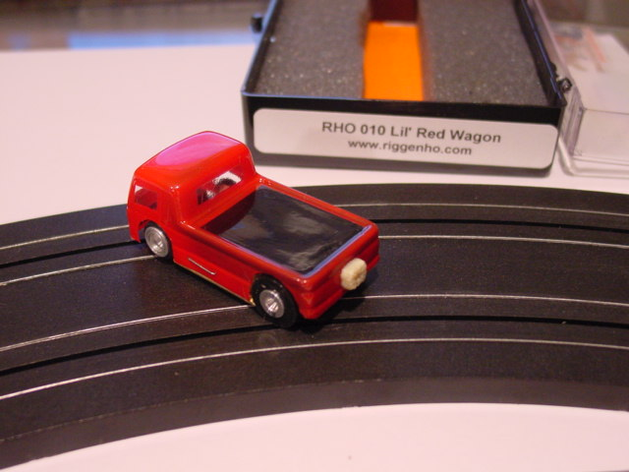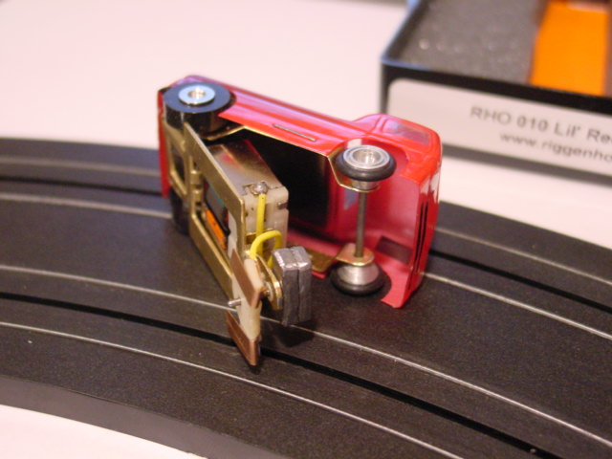
We had special plans for this body style, not wanting to let an opportunity for innovation go by so we decided to redesign the basic Riggen chassis to one that ACTUALLY WHEELIES!
We also have untrimmed painted bodies available in Red, Blue, Yellow and Metallic Light Red…Build your own! See more on the web at http://www.riggenho.com/LRW.htm (Limited supply)

RiggenHO Model Racing
Spring 2006, Volume 2 Issue 1

www.riggenho.com

Brass Wars
As you know, we are trying to rekindle interest in Old School style “Brass Wars” races where pro style non magnet cars (TycoPro, Riggen, Cobramite, Dynabrute and AFX modded Brass Pans) from the early 70’s compete. This was a very important time for HO scale slots as the benefits of traction magnets were just being explored and would shortly change the hobby forever. To date, we have had three races on the east Coast…another race is scheduled soon in Colorado. More information is on the web at http://www.riggenho.com/RacingSchedule.htm . If you are interested in staging your own Brass Wars for your race club, please contact us for ideas and info about our discount program.

FLASH: There is a BRASS WARS race scheduled for June 10 at NJ Nostalgia Hobby
Contact Joe Corea for details 908 322 2676

Frank Spena Super Modified Racer
The major benefit of running a “racing program” is that the heat of competition can bring out the best in your product. There is great learning to be had when putting your product in the hands of someone with the competitive drive to win, and willing to experiment, tinker, and invent over and over….We had that idea for our first Brass Wars Race….I was doing some web browsing about slot car racing and came upon the web site of Frank Spena. He has an impressive resume for sure! To make a long story short I somehow convinced Frank to race at our first Brass Wars race, and he and his sparring partner Dave Hendrickson came down to NJ Hobby last spring! Details of that event are on our web site (a successful outing) but as one thing always leads to another, Frank and Dave had some great ideas for improving the RiggenHO chassis for the next race….

A year later, those ideas have been incorporated (and race track proven!!!!) into a very limited (10 only and ever) special edition RiggenHO Super Modified RACE CAR. Frank went all out modding a RiggenHO chassis with EVERYTHING he thought would improve performance. Customizations include extensive work on the motor, the guide flag, and the body. Many many hours of testing and hand building go into each car.

There are 6 cars available, priced at $125 each.

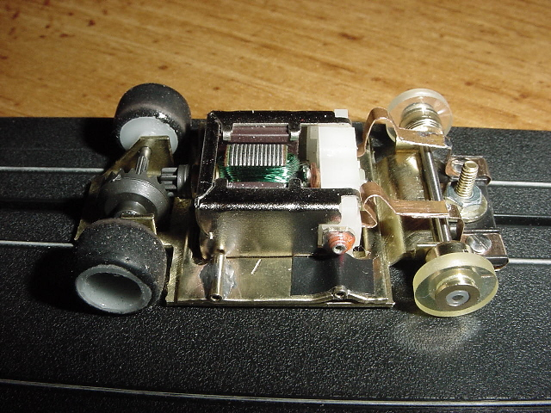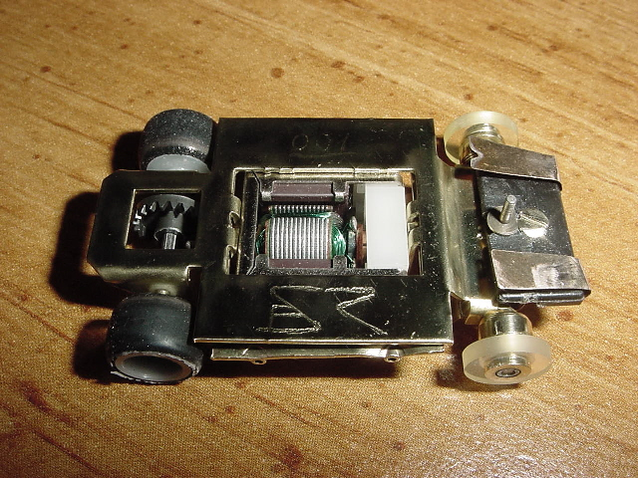

See more about this car including detailed pictures on the web here (http://www.riggenho.com/FSR.htm)

See the complete line RiggenHO Replacement Parts here

RiggenHO Model Racing
Spring 2006, Volume 2 Issue 1

www.riggenho.com

Collect:

The TycoPro Hop Up kits!

A Hop Up kit is the most natural product extension a slot car manufacturer can offer. It encourages tinkering and experimentation, it fuels an appetite for replacement parts, and most importantly, the right hop up parts can greatly improve performance! In contrast to Aurora’s T Jet Hop Up Kit which was largely comprised of replacement parts, (and encouraged shaving the wheel wells much to current collector’s dismay!!!) the TycoPro Hop Up kit responded to racer’s needs… brilliantly! This overlooked accessory is one of the greatest collector bargains around…not that easy to find complete, but they usually go for reasonable money and the increase in performance and appearance is totally worth the expense---not to mention the fun of working on your own chassis!
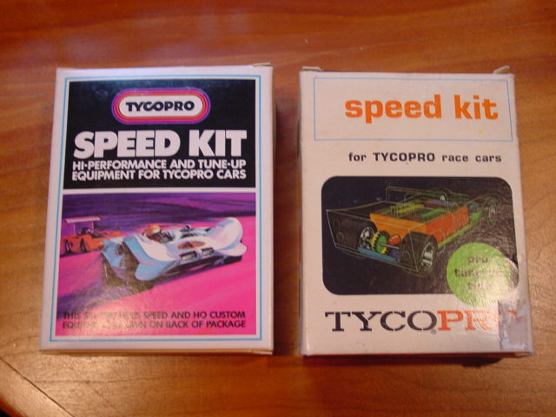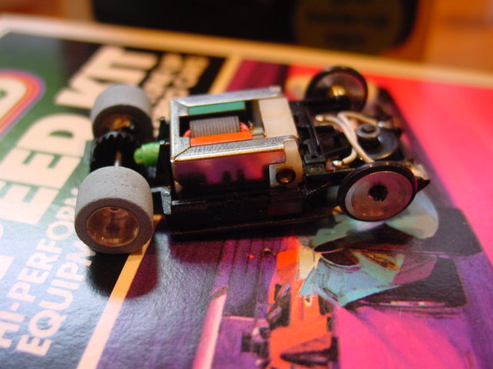
There were two packaging styles, old and new but both before TycoPro2 was introduced. The components of the kit are true hop ups. There are aluminum front rims with O rings that snap on, there are very nice rear aluminum hubs with flat head set screws and blue foam tires that came along with a very special axle. The axle has flattened ends to accommodate the set screws tightly. The kit also came with 2 crowns and two pinions so you could easily adjust your gear ratio to your track. The kit had spacers in it for the axles, another true racer hop up. In addition to car parts, the kit came with an eraser style track cleaner and the famous blue pen oiler. Decals, a product brochure and instructions completed this goody bag.

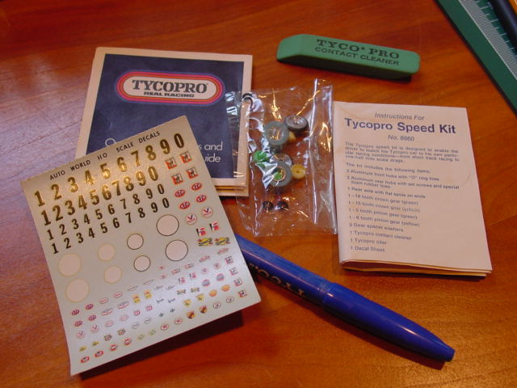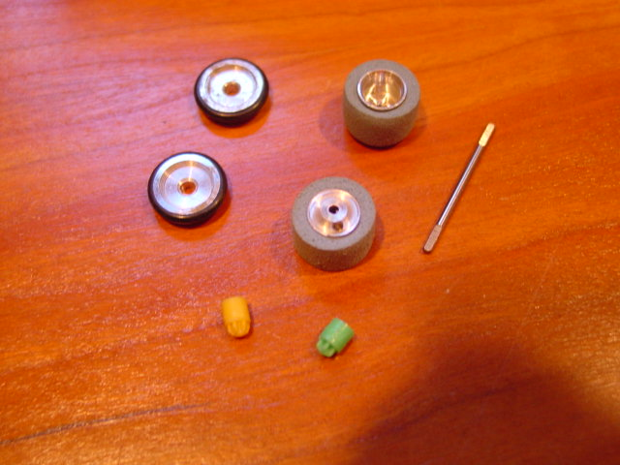

Get this kit if you can and hop up your TycoPro. Other TP goodies to look out for: green wire arms (besides the early copper and later red wire) and “Champion” tuned motors—look for the decal on the can!
……..Now that we think about it, RiggenHO needs to do a Hop Up kit! Stay Tuned!!!!!!

RiggenHO Model Racing

Spring 2006, Volume 2 Issue 1

www.riggenho.com

Useful and Interesting Links:

F-1, Indy car specialist: http://www.trackhobbies.com/Index.html
With a focus on collecting. Also promotes custom Resin work…
Slot Pro Speedway: http://www.slotprospeedway.com
Jim has painted some terrific vintage Riggen bodies for us. Highly recommended if he has capacity for your custom work.
The “Sikkest” collection I have yet to see….20 pages of slot cars and that is only one of his categories!: http://www.cyclesmithy.com
This is where all the other slot cars are—the boxed collection is insane…I counted more than 10 Mint Monogram 55 Chevy’s alone…sadly; no HO…..

From the Archives:

TCP Style Pan Cars from the Midwest (HOPRA-style)

Here are a couple of pictures of brass pan AFX modified cars. The intent of the design was to lower the center of gravity. These cars were raced with Lexan style plastic bodies and pin tubes. These were typically custom built from .032 hand cut brass or with parts from cottage industry companies like Tom Coyne Products (TCP). You can see the historical merging of the inline style TycoPro/Riggen brass pan with the Aurora pancake chassis. We’re just a heartbeat away from magnet cars now!

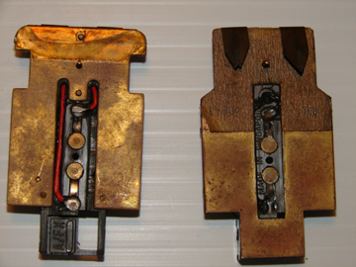 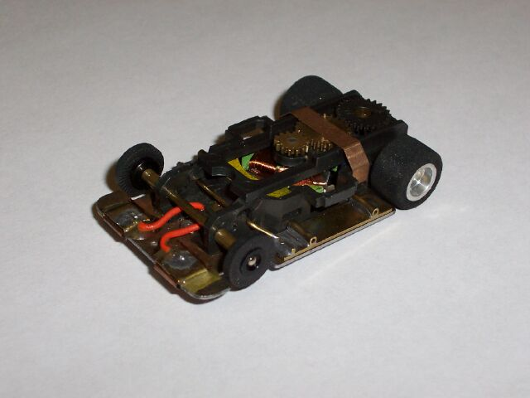
Collection John B Collection Doug M

…..More on these next issue!!!!!

