RiggenHO Model Racing
Race, Collect, Restore!
December 2005 Volume1 Issue 1

Welcome!
This is the first issue of our RiggenHO Model Racing Newsletter. We hope you find it to be useful and thought provoking. Each issue will packed with information to help you improve your RiggenHO race cars, give you some “behind the scenes” info about RiggenHO Model racing and expand your collecting knowledge. There will be regular sections such as: What’s New, Tech Tips, Collecting, as well as special features such as The Archive with photos and descriptions of rare or unusual items. We’ll conclude each issue with some recommended web site links to introduce you to a new product, idea, or just something we find interesting…
This newsletter is designed to be an interactive web-based media “guide” as well as a hard-copy newsletter. As long as you are connected to the web while reading this newsletter, clicking any link and most photos will redirect you to the relevant web page or a larger version of the photo.
Your feedback is important and many of our new products or improvements are a direct result of suggestions from our customers. Please contact us at RIGGENHO.COM.

Thanks for your support!
Ron Bernstein

RiggenHO.com New Products:

Mclaren GT body style 006
The McLaren GT is the 6th RiggenHO body style to be released. This is an original body style modeled by Gordon Brimhall and believed to be based upon the 1969 McLaren M6 GT. We are not sure if this was ever intended to be a Riggen Industries body style, or one that Brimhall was keeping for himself. You can find more information on this link…This is a unique body style with an interesting vintage racing and collecting heritage!

Independent Brass Fronts, Double Flanged Brass Screw On Rears
The “Brass + Can” theme (brass chassis-can motor) is the essence of the Riggen HO slot car. It was the development of these two features in a complimentary way that allowed Riggen Industries to dominate HO racing in the early 70’s---pre magnets of course! It’s only fitting to extend the “Brass” theme where possible, and we have done so with the introduction of a two new wheel sets:
First, we have a set of custom designed TAPERED BRASS Independent Front Wheels. These were custom milled for us to mimic the specs of the original Riggen Industries tapered front wheel set. Our set comes with 2 wheels, hardened steel axle, black Delrin

RiggenHO Model Racing
December 2005, Volume 1 Issue 1

www.riggenho.com

retainer caps and O Ring tires. They look great and add weight up front (approx 2 gms more than stock), very useful on tracks with a lot of tight turns to keep the front end in the slot. To compliment these, we offer a custom spec’d set of BRASS double flanged SCREW ON rear wheels. Our set comes with wheels, axle and brass 080 locking nuts. These are direct replacement parts for the stock aluminum wheels on the RiggenHO 2000 series chassis. They look great and add a little bit of extra weight to the rear end.

See all of our Replacement Parts here

Tech Tips:

Shaping the Guide Flag
The single most important tuning tip for your RiggenHO model race car is nailing down the optimal shape of your guide flag. The RiggenHO guide flag system is different from most HO scale race cars and very similar to most large scale slot cars. Instead of a pair of fixed pick ups attached to the chassis, the Riggen system uses a complete guide flag assembly with copper or beryllium wipers attached to a plastic wiper holder that rotates in a guide flag retainer hole. The lead wires are attached to the wipers directly and cross over behind the flag assembly and attach to the brush tubes at the sides. The crossed wires are “collector” correct and are important to be fitted this way because they add tension to the guide flag. This limits rotation (so your car doesn’t fishtail too much!) This “guide flag assembly” system is superior to a fixed pick up style (especially on today’s modern routed tracks with custom curve dimensions) because the rotation of the guide flag acts in concert with the changes of a track course and permits optimal contact between the wipers and the track at all times, not just on straights.
The best starting point for shaping your RiggenHO flag is fairly flat. Tweak the shape from here according to your track. If you use plastic (raised rail) track, “spread” your wipers little wide. The wide spreading helps assure that the flags don’t get hung along the side of the rails and optimally sit on top of the rails.
Re-check your flag shape after collisions with the wall or floor!
Whether you like a mostly flat wiper with a small downward flare at the rear edge (great for heavy cars; just make sure it’s not too springy) or a very flat and low shape (for tracks with long straights) PAY ATTENTION TO THE SHAPE OF YOUR FLAGS!
When the flag gets too worn (deep grooves, missing chips) replace them!
See More Tuning and Assembly Tips here

RiggenHO Model Racing
December 2005, Volume 1 Issue 1

www.riggenho.com

Collect:

“Style 2” Cars that few know about…

If you have collected Riggen, you know that many of the body styles actually have two different versions. Generally speaking, Version 1 cars were early designs and tend to run
the narrow side—sometimes a little too narrow and can look funny on the chassis. Version 2 cars were likely released in 1972-1973 and usually feature less detail than early version (they appear more “blocky”) as well as having a wider fit. Most collectors are aware of a number of the Version 1/Version 2 comparisons from the Riggen Boss HO Series Poster produced by Dan Esposito but there were a couple of version 2 cars that didn’t make the poster! Go check your collection and see what you may be missing!
Everyone knows about the Mustang…but what about the Firebird, the Mini Cooper, and the Mid Engine Vette? (Click the picture)

Interesting Links:

Art-Kit Slot Tracklights: http://www.art-kitslot.com
Unfortunately only is Spanish at the moment…These are the best tracklights I have seen anywhere. I haven’t tested them yet (I just found the link) but I will soon.

Overdrive: http://www.slotservice.com/slotservice/ss_frameset_e.htm
Another foreign language site…Here is a great 1/32 in-car lighting system that looks like it is small enough to be adopted for HO. We have done a lighted RiggenHO chassis by soldering in the typical “grain of wheat” bulbs between the leads and the motor…but we can do better!

HO Race Pro: http://www.horacepro.com/rattler.html
If you started from scratch to build a new chassis from brass and use a shaker plate like Riggen did…. perhaps here is where you would end up! Check out the Rattler 2

RiggenHO Model Racing
December 2005, Volume 1 Issue 1

www.riggenho.com

From the Archives:

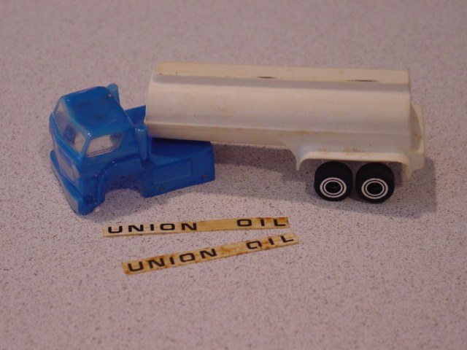

Prototype Oil Tanker
This car was part of a very important collection recently acquired by RiggenHO.com. In 1972, Gayla Industries purchased Riggen Industries and continued for a short while after that making HO slot cars (Riggen Industries was sold again in the mid 70’s To REH who continues to market Riggen 1/32 slot cars and track). We met the former Vice President of Gayla Industries who had a small collection of Riggen HO cars from the time and discussed the history of Riggen Industries relating to HO slots.
The tanker you see here is a Riggen Industries prototype, believed to be unique. The tanker was most likely a line extension of the Hot Rod Series, the first truck being the Riggen TT-1 Tractor Trailer. The tank itself is made of the same material as Tractor Triler and the wheel assembly of the tank is also the same. Also of note is the Union Oil sticker, printed in the same font as Riggen Industries on the Tractor Trailer. This truck came to us with the cab body you see here.

